**2nd Lt David Crow**

**ENG/20M**

**CSCE 560**

**Socket Programming Assignment 1**

**TCP Client and Server**

**Fall 18**

**Results of netstat -nao**

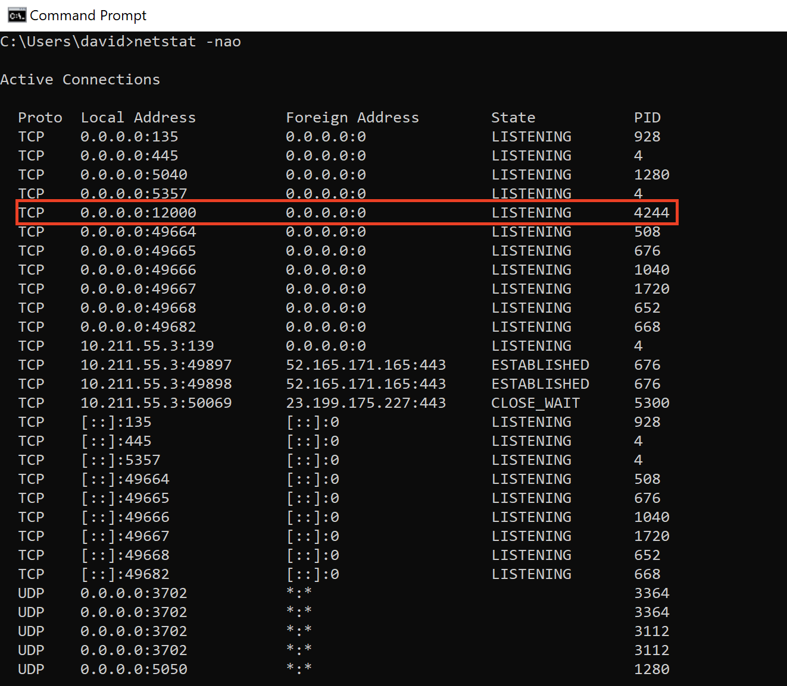

**Server output**



**Client output**

